South Sound LASER Alliance
Next Generation Science Standards 101:
Part 4: Engineering Design

Participant Handbook

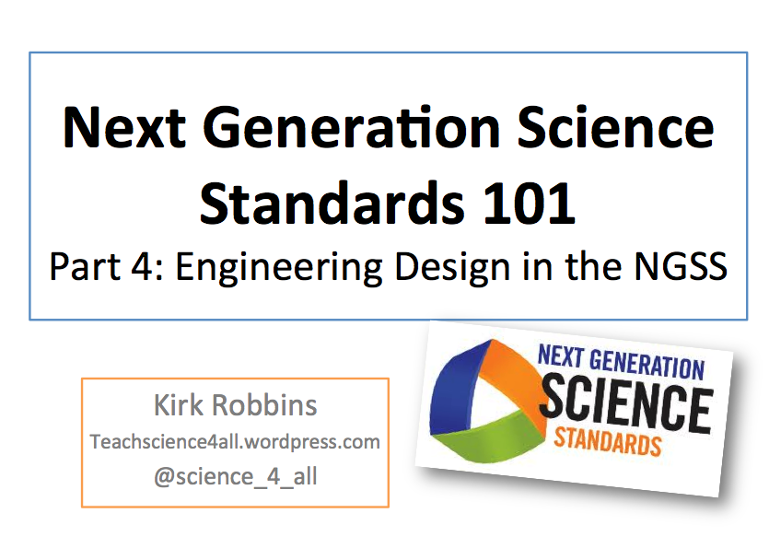
Our Initial Ideas about Engineering

What is your background as a learner of Engineering?
What is your experience as a teacher of Engineering?
What are some important Engineering terms and concepts that we should be teaching students?

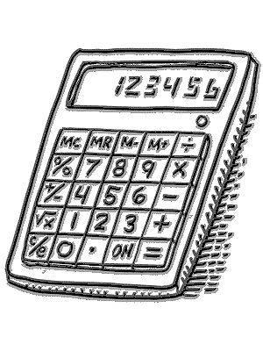
Is it Technology?

Which of the following are examples of TECHNOLOGY?

____ | Laptop | ____ | Toilet
____ | Stapler | ____ | Volcano
____ | Written language | ____ | Farming
____ | Guitar | ____ | Lamp
____ | Lightning | ____ | Pencil
____ | Habitat | ____ | Seeds
____ | Sticky note | ____ | Cell phone
____ | Projector | ____ | Mars
____ | Tree | ____ | Telescope

Describe your rule for something to be considered TECHNOLOGY. Use evidence and reasoning to support your claim.
__________________________________________________________________________________________________

__________________________________________________________________________________________________

__________________________________________________________________________________________________

__________________________________________________________________________________________________

__________________________________________________________________________________________________

__________________________________________________________________________________________________

__________________________________________________________________________________________________

__________________________________________________________________________________________________
What Do Engineers Do?

Which of the following is the best description of what engineers do?

_____ Engineers solve problems

_____ Engineers make things

_____ Engineers invent new products

_____ Engineers fix machines

_____ Engineers do experiments

_____ Engineers build bridges and airplanes

_____ Engineers drive trains

Describe your thinking. Provide an explanation for your answer.
__________________________________________________________________________________________________

__________________________________________________________________________________________________

__________________________________________________________________________________________________

__________________________________________________________________________________________________

__________________________________________________________________________________________________

__________________________________________________________________________________________________

__________________________________________________________________________________________________

__________________________________________________________________________________________________

__________________________________________________________________________________________________

__________________________________________________________________________________________________

__________________________________________________________________________________________________

Overview and Background Information on Engineering in the Next Generation Science Standards
The following information provides background on Engineering Design in the Next Generation Science Standards.

Important Terminology and Text from Appendix I of NGSS
Technology: we broadly use the term “technology” to include all types of human-made systems and processes—not in the limited sense often used in schools that equates technology with modern computational and communications devices. Technologies result when engineers apply their understanding of the natural world and of human behavior to design ways to satisfy human needs and wants.

Engineering: We use the term “engineering” in a very broad sense to mean any engagement in a systematic practice of design to achieve solutions to particular human problems.

Science: is generally taken to mean the traditional natural sciences: physics, chemistry, biology, and (more recently) earth, space, and environmental sciences

Engineering Design in the Framework

The term “engineering design” has replaced the older term “technological design,” consistent with the definition of engineering as a systematic practice for solving problems, and technology as the result of that practice. According to the Framework: “From a teaching and learning point of view, it is the iterative cycle of design that offers the greatest potential for applying science knowledge in the classroom and engaging in engineering practices” (NRC 2012, pp. 201-2). The Framework recommends that students explicitly learn how to engage in engineering design practices to solve problems.

The Framework also projects a vision of engineering design in the science curriculum, and of what students can accomplish from early school years to high school:

In some ways, children are natural engineers. They spontaneously build sand castles, dollhouses, and hamster enclosures, and they use a variety of tools and materials for their own playful purposes. …Children’s capabilities to design structures can then be enhanced by having them pay attention to points of failure and asking them to create and test redesigns of the bridge so that it is stronger. (NRC, 2012, p. 70).

By the time these students leave high school, they can “undertake more complex engineering design projects related to major global, national, or local issues” (NRC, 2012, p. 71). The core idea of engineering design includes three component ideas:

3 Components of Engineering Design:
A. Defining and delimiting engineering problems involves stating the problem to be solved as clearly as possible in terms of criteria for success, and constraints or limits.

B. Designing solutions to engineering problems begins with generating a number of different possible solutions, then evaluating potential solutions to see which ones best meet the criteria and constraints of the problem.

C. Optimizing the design solution involves a process in which solutions are systematically tested and refined and the final design is improved by trading off less important features for those that are more important.

Engineering Design in Grades K-2
Engineering design in the earliest grades introduces students to “problems” as situations that people want to change. They can use tools and materials to solve simple problems, use different representations to convey solutions, and compare different solutions to a problem and determine which is best. Students in all grade levels are not expected to come up with original solutions, although original solutions are always welcome. Emphasis is on thinking through the needs or goals that need to be met, and which solutions best meet those needs and goals.

Engineering Design as Core Ideas K-2 (ETS)
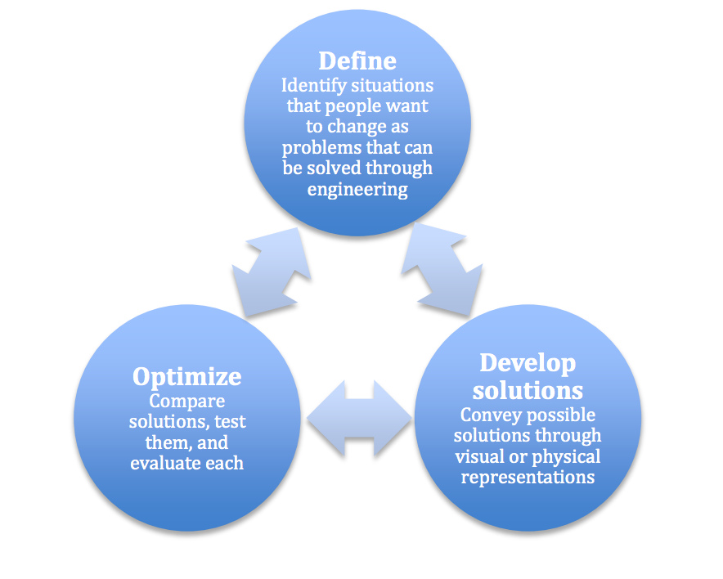
____ K-2-ETS1-1 Ask questions, make observations, and gather information about a situation people want to change to define a simple problem that can be solved through the development of a new or improved object or tool.

____ K-2-ETS1-2 Develop a simple sketch, drawing, or physical model to illustrate how the shape of an object helps it function as needed to solve a given problem.

____ K-2-ETS1-3 Analyze data from tests of two objects designed to solve the same problem to compare the strengths and weaknesses of how each performs.

NGSS Performance Expectations with Engineering connections
(There are 5 PEs with engineering connections in grades K-2)

K-PS2-2. | Analyze data to determine if a design solution works as intended to change the speed or direction of an object with a push or a pull.
K-ESS3-2. | Ask questions to obtain information about the purpose of weather forecasting to prepare for, and respond to, severe weather
K-ESS3-3. | Communicate solutions that will reduce the impact of humans on the land, water, air, and/or other living things in the local environment.
2-LS2-2. | Develop a simple model that mimics the function of an animal in dispersing seeds or pollinating plants.
2-ESS2-1. | Compare multiple solutions designed to slow or prevent wind or water from changing the shape of the land.

Engineering Design in Grades 3-5
At the upper elementary grades, engineering design engages students in more formalized problem solving. Students define a problem using criteria for success and constraints or limits of possible solutions. Students research and consider multiple possible solutions to a given problem. Generating and testing solutions also becomes more rigorous as the students learn to optimize solutions by revising them several times to obtain the best possible design.

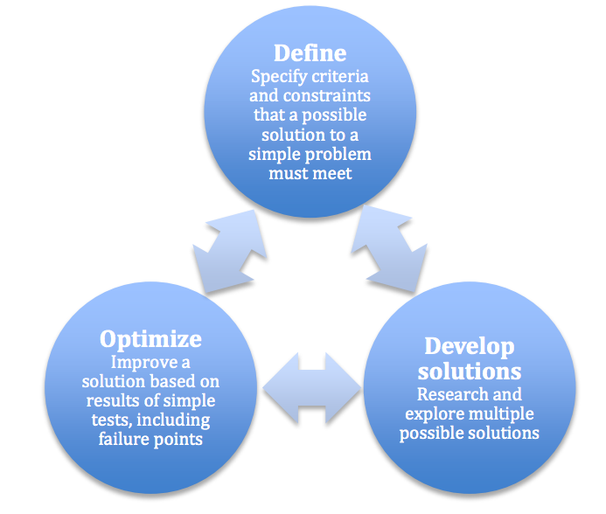
Engineering Design as Core Ideas 3-5 (ETS)
____ 3-5-ETS1-1 Define a simple design problem reflecting a need or a want that includes specified criteria for success and constraints on materials, time, or cost.

____ 3-5-ETS1-2 Generate and compare multiple possible solutions to a problem based on how well each is likely to meet the criteria and constraints of the problem.

____ 3-5-ETS1-3 Plan and carry out fair tests in which variables are controlled and failure points are considered to identify aspects of a model or prototype that can be improved.

NGSS Performance Expectations with Engineering connections
(There are 6 PEs with engineering connections in 3-5)

____ 3-PS2-4 Define a simple design problem that can be solved by applying scientific ideas about magnets.

____ 3-LS4-4 Make a claim about the merit of a solution to a problem caused when the environment changes and the types of plants and animals that live there may change.

____ 3-ESS3-1 Make a claim about the merit of a design solution that reduces the impacts of a weather-related hazard.

____ 4-PS3-4 Apply scientific ideas to design, test, and refine a device that converts energy from one form to another

____ 4-PS4-3 Generate and compare multiple solutions that use patterns to transfer information.

____ 4-ESS3-2 Generate and compare multiple solutions to reduce the impacts of natural Earth processes on humans.

Engineering Design in Grades 6-8
At the middle school level, students learn to sharpen the focus of problems by precisely specifying criteria and constraints of successful solutions, taking into account not only what needs the problem is intended to meet, but also the larger context within which the problem is defined, including limits to possible solutions. Students can identify elements of different solutions and combine them to create new solutions. Students at this level are expected to use systematic methods to compare different solutions to see which best meet criteria and constraints, and to test and revise solutions a number of times in order to arrive at an optimal design.

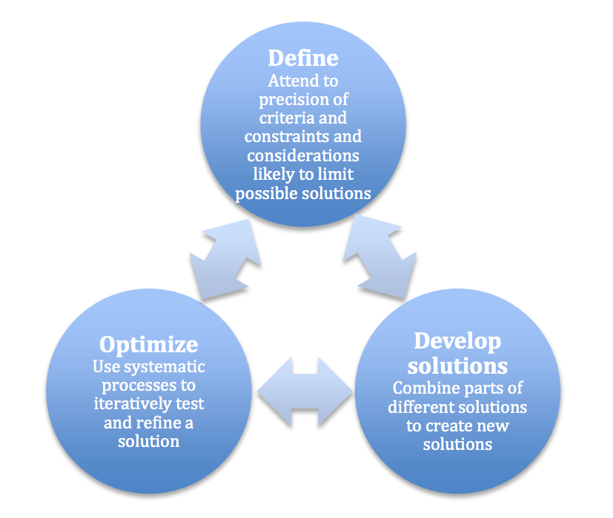
Engineering Design as Core Ideas 6-8 (ETS)
____ MS-ETS1-1 Define the criteria and constraints of a design problem with sufficient precision to ensure a successful solution, taking into account relevant scientific principles and potential impacts on people and the natural environment that may limit possible solutions.

___ MS-ETS1-2 Evaluate competing design solutions using a systematic process to determine how well they meet the criteria and constraints of the problem.

___ MS-ETS1-3 Analyze data from tests to determine similarities and differences among several design solutions to identify the best characteristics of each that can be combined into a new solution to better meet the criteria for success.

___ MS-ETS1-4 Develop a model to generate data for iterative testing and modification of a proposed object, tool, or process such that an optimal design can be achieved

NGSS Performance Expectations with Engineering connections
(There are 4 PEs with engineering connections in 6-8)

____ MS-PS1-6 Undertake a design project to construct, test, and modify a device that either releases or absorbs thermal energy by chemical processes.

____ MS-PS2-1 Apply Newton’s Third Law to design a solution to a problem involving the motion of two colliding objects.

____ MS-PS3-3 Apply scientific principles to design, construct, and test a device that either minimizes or maximizes thermal energy transfer.

____ MS-LS2-5 Evaluate competing design solutions for maintaining biodiversity and ecosystem services.

Engineering Design in Grades 9-12
Engineering design at the high school level engages students in complex problems that include issues of social and global significance. Such problems need to be broken down into simpler problems to be tackled one at a time. Students are also expected to quantify criteria and constraints so that it will be possible to use quantitative methods to compare the potential of different solutions. While creativity in solving problems is valued, emphasis is on identifying the best solution to a problem, which often involves researching how others have solved it before. Students are expected to use mathematics and/or computer simulations to test solutions under different conditions, prioritize criteria, consider trade-offs, and assess social and environmental impacts.

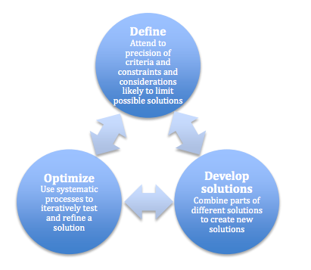
Engineering Design as Core Ideas 6-8 (ETS)
____ HS-ETS1-1 Analyze a major global challenge to specify qualitative and quantitative criteria and constraints for solutions that account for societal needs and wants.
___ HS-ETS1-2 Design a solution to a complex real-world problem by breaking it down into smaller, more manageable problems that can be solved through engineering.
___ HS-ETS1-3 Evaluate a solution to a complex real-world problem based on prioritized criteria and trade-offs that account for a range of constraints, including cost, safety, reliability, and aesthetics as well as possible social, cultural, and environmental impacts.
___HS-ETS1-4 Use a computer simulation to model the impact of proposed solutions to a complex real-world problem with numerous criteria and constraints on interactions within and between systems relevant to the problem.

NGSS Performance Expectations with Engineering connections
(There are 6 PEs with engineering connections in High School)
HS-PS1-6. | Refine the design of a chemical system by specifying a change in conditions that would produce increased amounts of products at equilibrium.
HS-PS2-3. | Apply scientific and engineering ideas to design, evaluate, and refine a device that minimizes the force on a macroscopic object during a collision.
HS-PS3-3. | Design, build, and refine a device that works within given constraints to convert one form of energy into another form of energy.
HS-LS2-7. | Design, evaluate, and refine a solution for reducing the impacts of human activities on the environment and biodiversity
HS-LS4-6. | Create or revise a simulation to test a solution to mitigate adverse impacts of human activity on biodiversity.
HS-ESS3-2. | Evaluate competing design solutions for developing, managing, and utilizing energy and mineral resources based on cost-benefit ratios.

Two students solve the case of the watery ketchup by designing a new cap
BY LINDSEY FOAT, THE HALE CENTER FOR JOURNALISM AT KCPT May 12, 2014
High school seniors Tyler Richards and Jonathan Thompson have spent a lot of time thinking about ketchup.
As students in the Project Lead the Way program at North Liberty High School in Liberty, Missouri, Richards and Thompson have researched and developed a bottle cap that prevents that first squirt of ketchup from being a watery mess.
“Wet bread is gross,” said Thompson, explaining why they decided to tackle the problem.
Project Lead the Way is a national program that takes a hands-on and project-based approach to STEM education for elementary, middle and high school students.
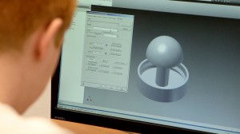
“I get to turn the kids loose, let them be creative and find innovative solutions to problems,” said Brett Kisker, who teaches Project Lead the Way classes at North Liberty.
“The prompt was that they had to come up with something that was relevant to them. So we always start with the phrase, ‘it really bugs me when.’”
Kisker was skeptical when Richards and Thompson first suggested their problem.
“I said that they could just shake the bottle and that there is a free solution,” Kisker said. “But they did a lot of research and they had me convinced that this problem really does exist.”
After some initial surveys indicated that others shared their distaste for the problem, Richards and Thompson reviewed existing patents involving ketchup.
“There are a surprising amount of ketchup-related patents out there,” Richards said. “There was one — it’s kind of hard to explain — but basically it’s a way to inject ketchup into a french fry. It was a bit extreme.”
Having poured over patents to verify that a solution didn’t already exist, they each sketched out 30 different ideas for a design.
From 60 potential designs they narrowed it down to five, and then to a final design that they affectionately refer to as “the mushroom” or “the shroom.”
“It is based on the pythagorean cup idea,” Thompson said. “It’s also the same principle that toilets work off of.”
The prototype, which they made using a 3-D printer, resembles a regular cap for a squeezable ketchup bottle except for what looks like an upside down mushroom on the underside of the cap.
“Basically kind of what’s happening is that there is no way the ketchup can go through there,” Richards said, pointing to the portion resembling a mushroom top. “So (the pressure) pushes it up and over it. Then the water sits in this little basin right here and the ketchup comes out.”
Market research conducted by the students indicates that this mushroom cap could be made for 22.6 cents and that consumers might be willing to pay up to $3.00 for the solution.
Despite the potential profits, Richards and Thompson have focused most of their energy on perfecting their design, and less on what sorts of patents or business ventures they might pursue.
“Mostly it’s just been fun,” Richards said. “There’s not many classes where you can do a year-long research project on ketchup.”
Richards and Thompson exhibited the fruits of their labor along with about 250 area high school seniors in April at the Project Lead the Way Senior Showcase in Kansas City.
Come June, Thompson is headed to Army basic training and Richards plans to attend Missouri University of Science and Technology in August.

STEM Video Case
Use the space below to take notes on the STRATEGIES used by the teacher in the video.

Strategy | Notes | How I might modify this strategy for my grade level?

Final Reflections

What are 3 things you LEARNED in this session Engineering Design?

What is one SHIFT you will make in your work with students to add more Engineering opportunities?

What is one thing you still WANT to learn or know about the Engineering Design in the NGSS?

