K-5 Systems Standards:
A Handbook for Learning & Teaching
Systems Thinking

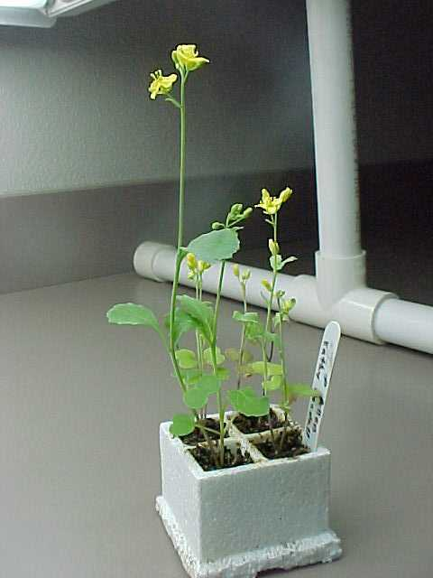
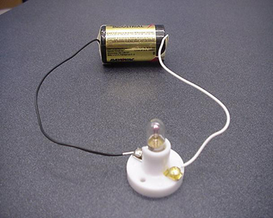

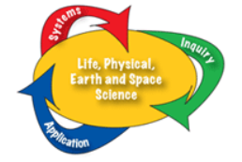

Version 1.1
Winter 2012
Table of Contents

Introduction

Preface: Why Systems? Why a Handbook?

Background on Systems

Systems in Washington Standards

Systems in Washington State Science Learning Standards

Systems in Washington State 5th Grade Test & Item Specs

Resources of Instruction

Systems Questions for Classroom Discourse

Systems Frameworks (ESD 112)

Systems Example Lessons
- Systems Centers
- Pendulum System
- Toy Boat Literacy Lesson

Opportunities for Teaching Systems Standards in FOSS Kits

Assessment Tools
Sample Systems 5th Grade MSP Scenarios

Systems Standards Based Rubrics

Appendix A: Systems Vocabulary- Sample List

Appendix B: Systems Online Resources

Preface: Why Systems? Why a Handbook?

Most of us did not learn science through the lens of “systems”. Therefore it may be a difficult shift to think about teaching systems ideas. Systems standards may not seem like “real” science to us since it is a content that we are less familiar with. However, we need to fight this urge and embrace the teaching of systems thinking. These habits of mind, practices, and ways of thinking will prepare our students with the 21st century skills they need to be college and career ready as well as scientifically literate.

Why teach Systems?
- Cross Cutting Idea (EARL 1) in WA Science Learning Standards (2009)
- Theme in 2061 resources: Science Benchmarks, Science for All Americans, Atlases of Science Literacy..
- Cross Cutting Idea in the Framework for K-12 Science Education (upcoming Next Generation Science Standards)
- Provides a framework for connecting multiple core ideas in science
- Promotes 21st Century Skills
- Environmental Science connections see Environmental & Sustainability Learning Standards

Why a Handbook?
- There are limited intentional lessons that teach systems concepts in K-5 science instructional materials. Luckily, there are lots of opportunities if we know what to look for. This handbook intends to help us identify those opportunities.
- There are many great resources for teaching system ideas, but they are not well organized. This handbook is an initial attempt to provide some organization and ease of use.
- Organizing instructional supports will benefit districts, schools, teachers and students in learning and teaching systems ideas.
Systems… is a way of thinking that makes it possible to analyze and understand complex phenomena.

Excerpt from Washington State Science Learning Standards 2009
- The existence of a handbook dedicated to systems raises the awareness of the importance of systems standards which may be overshadowed by traditional science content domains (biology, chemistry, physics, etc).

Background on Systems
The following selections provide a variety of perspectives, definitions, and areas of focus to consider as we engage with systems standards.

AAAS Definition from Science for All Americans
Any collection of things that have some influence on one another can be thought of as a system. The things can be almost anything, including objects, organisms, machines, processes, ideas, numbers, or organizations. Thinking of a collection of things as a system draws our attention to what needs to be included among the parts to make sense of it, to how its parts interact with one another, and to how the system as a whole relates to other systems. Thinking in terms of systems implies that each part is fully understandable only in relation to the rest of the system.

Systems Overview from Benchmarks Online
One of the essential components of higher-order thinking is the ability to think about a whole in terms of its parts and, alternatively, about parts in terms of how they relate to one another and to the whole. People are accustomed to speak of political systems, sewage systems, transportation systems, the respiratory system, the solar system, and so on. If pressed, most people would probably say that a system is a collection of things and processes (and often people) that interact to perform some function. The scientific idea of a system implies detailed attention to inputs and outputs and interactions among the system components. If these can be specified quantitatively, a computer simulation of the system might be run to study its theoretical behavior, and so provide a way to define problems and investigate complex phenomena. But a system need not have a "purpose" (e.g., an ecosystem or the solar system) and what a system includes can be imagined in any way that is interesting or useful. Students in the elementary grades study many different kinds of systems in the normal course of things, but they should not be rushed into explicit talk about systems. That can and should come in middle and high school.

Children tend to think of the properties of a system as belonging to individual parts of it rather than as arising from the interaction of the parts. A system property that arises from interaction of parts is therefore a difficult idea. Also, children often think of a system only as something that is made and therefore as obviously defined. This notion contrasts with the scientific view of systems as being defined with particular purposes in mind. The solar system, for example, can be defined in terms of the sun and planets only, or defined to include also the planetary moons and solar comets. Similarly, not only is an automobile a system, but one can think of an automotive system that includes service stations, oil wells, rubber plantations, insurance, traffic laws, junk yards, and so on.

The main goal of having students learn about systems is not to have them talk about systems in abstract terms, but to enhance their ability (and inclination) to attend to various aspects of particular systems in attempting to understand or deal with the whole system. Does the student troubleshoot a malfunctioning device by considering connections and switches—whether using the terms input, output, or controls or not? Does the student try to account for what becomes of all of the input to the water cycle—whether using the term conservation or not? The vocabulary will be helpful for students once they have had a wide variety of experiences with systems thinking, but otherwise it may mistakenly give the impression of understanding. Learning about systems in some situations may not transfer well to other situations, so systems should be encountered through a variety of approaches, including designing and troubleshooting. Simple systems (a pencil or mousetrap), of course, should be encountered before more complex ones (a stereo system, a plant, the continuous manufacture of goods, ecosystems, or school government).
Art Sussman: from Dr. Art’s Guide to Science

A system exists whenever parts combine or connect with each other to form a whole. The whole is QUALITATIVELY more than the sum of its parts.

You, your circulatory system, water, and table salt are all examples of systems

Questions to Ask About Systems
1. What are the parts of the system?
2. How does the system function as a whole?
3. How is the system part of larger systems?

A persistent student misconception is that the properties of an assembly are the same as the properties of its parts (for example, that soft materials are made of soft molecules). Sometimes it is true. For example, a politically conservative organization may be made up entirely of conservative individuals. But some features of systems are unlike any of their parts. Sugar is sweet, but its component atoms (carbon, oxygen, and hydrogen) are not. The system property may result from what its parts are like, but the parts themselves may not have that property. A grand example is life as an emergent property of the complex interaction of complex molecules.

Systems in Washington Science Learning Standards
Cross-cutting | EALR 1  Systems
The Big Ideas of Science | …is a way of thinking that makes it possible to analyze and understand complex phenomena.
Grades  9-12 | Predictability  and Feedback
 | Create realistic models with feedback, and recognize that all models are limited in their predictive power.
Grades  6-8 | Inputs, Outputs,  Boundaries & Flows
 | Look at a complex situation and see how it can be analyzed as systems with boundaries, inputs, outputs, and flows.
Grades  4-5 | Complex  Systems
 | Analyze a system in terms of subsystems functions and input and outputs.
Grades  2-3 | Role of Each Part  in a System
 | See how parts of objects, plants, and animals are connected and work together.
Grades  K-1 | Part-Whole  Relationships
 | Identify parts of living and non-living systems.
This page provides:
- a vertical look at how systems ideas progress K-12
- an overview of the origins of systems thinking
- a definition of systems as a “way of thinking”
Systems. The idea of systems analysis arose first in the life sciences, where the reductionist methods of physics failed to account for the many interactions among organisms and their environments. Later, Earth and Space Science adopted a view of our planet as four interacting systems—the rocky geosphere, the watery hydrosphere, the atmosphere, and the biosphere. Systems thinking also has many applications in physics. In addition to its use within domains, systems thinking provides a bridge between science domains. In elementary school students learn to think systematically about how the parts of objects, plants, and animals are connected and work together, noting that properties of a whole object or organism are different from the properties of its parts and that if one or more parts are removed, the whole system may fail. In upper elementary school, students learn that systems contain smaller (sub-) systems, and they are also parts of larger systems. In middle school the focus is on more complex ideas including systems boundaries, open and closed systems, and the flow of matter and energy through systems. In high school students learn to use the concept of feedback in developing models of systems and recognize that new and unpredictable properties may emerge in complex systems. Students can apply this more sophisticated understanding to analyzing real-world societal issues, which in turn helps them further develop their “systems thinking” abilities. The aim of this sequence of standards is for every student to be ready and able to use systems thinking whenever they encounter a complex problem with numerous factors and interconnections.

Systems in Washington Science Learning Standards
Grade K-1

EALR 1: Systems
Big Idea: Systems (SYS)
Core Content: Part-Whole Relationships

In grades K-1, students gain fluency in using the concept of part-whole relationships. They agree on names for the parts that make up several types of whole objects, including plants and animals. They learn that objects can be easily taken apart and put back together again, while other objects cannot be taken apart and reassembled without damaging them. Removing one or more parts will usually change how the object functions. Fluency with the part-whole relationship is essential for all of the sciences and is an important building block for more sophisticated understanding of how systems operate in natural and designed environments.

 | Content Standards | Performance Expectations
 | Students know that: | Students are expected to:
K-1 SYSA | Living and nonliving things are made of parts. People give names to the parts that are different from the name of the whole object, plant, or animal. | - Name at least five different parts, given an illustration of a whole object, plant, or animal.  - Compare a part of an object with the whole object, correctly using the words “whole” and “part.”
K-1 SYSB | Some objects can easily be taken apart and put back together again while other objects cannot be taken apart without damaging them (e.g., books, pencils, plants, and animals). | - Identify which of several common objects may be taken apart and put back together without damaging them (e.g., a jigsaw puzzle) and which objects cannot be taken apart without damaging them (e.g., books, pencils, plants, and animals). *a

Systems in Washington Science Learning Standards
Grade 2-3
EALR 1: Systems
Big Idea: Systems (SYS)
Core Content: Role of Each Part in a System
In prior grades students learned to recognize part-whole relationships. In grades 2-3 students learn to think systematically about how the parts of objects, plants, and animals are connected and work together. They realize that the whole object, plant, or animal has properties that are different from the properties of its parts, and that if one or more parts are removed, the whole system may not continue functioning the same way. Students also note cases in which the same part may play a different role in a different system. Finally, they learn to define system as “a group of interacting parts that form a whole.” Understanding that an object, plant, or animal is more than the sum of its parts is a deep insight that has value in investigating all natural and human-made systems.

 | Content Standards | Performance Expectations
 | Students know that: | Students are expected to:
2-3 SYSA | A system is a group of interacting parts that form a whole. | - Give examples of simple living and physical systems (e.g., a whole animal or plant, a car, a doll, a table and chair set). For each example, explain how different parts make up the whole.
2-3 SYSB | A whole object, plant, or animal may not continue to function the same way if some of its parts are missing. | - Predict what may happen to an object, plant, or animal if one or more of its parts are removed (e.g., a tricycle cannot be ridden if its wheels are removed).*a  - Explain how the parts of a system depend on one another for the system to function.
2-3 SYSC | A whole object, plant, or animal can do things that none of its parts can do by themselves. | - Contrast the function of a whole object, plant, or animal with the function of one of its parts (e.g., an airplane can fly, but wings and propeller alone cannot; plants can grow, but stems and flowers alone cannot).
2-3 SYSD | Some objects need to have their parts connected in a certain way if they are to function as a whole. | - Explain why the parts in a system need to be connected in a specific way for the system to function as a whole (e.g., batteries must be inserted correctly in a flashlight if it is to produce light).
2-3 SYSE | Similar parts may play different roles in different objects, plants, or animals. | - Identify ways that similar parts can play different roles in different systems (e.g., birds may use their beaks to crack seeds while other birds use their beaks to catch fish).

Systems in Washington Science Learning Standards
Grade 4-5
EALR 1: Systems
Big Idea: Systems (SYS)
Core Content: Complex Systems
In prior grades students learned to think systematically about how the parts of objects, plants, and animals are connected and work together. In grades 4-5 students learn that systems contain smaller (sub-) systems, and that systems are also parts of larger systems. The same ideas about systems and their parts learned in earlier grades apply to systems and subsystems. In addition, students learn about inputs and outputs and how to predict what may happen to a system if the system’s inputs are changed. The concept of a hierarchy of systems provides a conceptual bridge for students to see the connections between mechanical systems (e.g., cities) and natural systems (e.g., ecosystems).

 | Content Standards | Performance Expectations
 | Students know that: | Students are expected to:
4-5 SYSA | Systems contain subsystems. | - Identify at least one of the subsystems of an object, plant, or animal (e.g., an airplane contains subsystems for propulsion, landing, and control).
4-5 SYSB | A system can do things that none of its subsystems can do by themselves. | - Specify how a system can do things that none of its subsystems can do by themselves (e.g., a forest ecosystem can sustain itself, while the trees, soil, plant, and animal populations cannot).
4-5 SYSC | Systems have inputs and outputs. Changes in inputs may change the outputs of a system. | - Describe what goes into a system (input) and what comes out of a system (output) (e.g., when making cookies, inputs include sugar, flour, and chocolate chips; outputs are finished cookies).  - Describe the effect on a system if its input is changed (e.g., if sugar is left out, the cookies will not taste very good).
4-5 SYSD | One defective part can cause a subsystem to malfunction, which in turn will affect the system as a whole. | - Predict what might happen to a system if a part in one or more of its subsystems is missing, broken, worn out, mismatched, or misconnected (e.g., a broken toe will affect the skeletal system, which can greatly reduce a person’s ability to walk).*a

Systems in Washington State 5th Grade Test & Item Specs

EALR 1: Systems
Big Idea: Systems (SYS)
Core Content: Complex Systems
Stimulus and Stem Rules

- A stimulus or stem will include an adequate description of an appropriate physical, Earth/space, and/or life science system.
Item Specifications

 | Items may ask students to: | C.C. | Format
4-5 SYSA  Systems & Subsystems | - Identify one or more subsystems of a given system (e.g., the brakes in a bike system, water in an earth system). | 2 | MC
4-5 SYSB  Functions of Systems | - Describe a function of a given system that any one of its subsystems is unable to do by itself (e.g., a bicycle can move forward, but the seat cannot move forward alone). | 2 | MC
4-5 SYSC  Inputs & Outputs of Systems | - Describe one or more inputs and/or outputs of a given system (e.g., pushing on a pedal is an input, and the wheel moving is an output in a bicycle system; hitting a drum is an input and the sound of the drum is an output of a drum system). | 2 | MC  CP  SA
4-5 SYSC  Inputs & Outputs of Systems | - Predict how changing an input to a given system might change the system (e.g., moving legs faster while on a swing makes the swing go higher). | 2 | MC  SA
4-5 SYSD  Changes to Parts of a System | - Predict what might happen to a given system if a part in one or more of its subsystems is missing, broken, worn out, mismatched, or misconnected (e.g., if a wheel is broken a toy car will not move forward; if a battery is missing an electronic toy will not make sound). | 2 | MC  SA

Questions to Ask About Systems (Project 2061)
The following is a list of questions in order of increasing complexity. These support our WA Science Learning Standards and provide a source of “on the fly” systems questions as well as a resource for lesson planning.

a. When this system is working, what does it do?
b. For this system to work, must it receive any input?
Use these questions to infuse some systems thinking into your science lessons.
c. What, if any, output does this system produce?
d. Identify at least four parts of this system. Describe what each part does, and tell how each part contributes to the system as a whole.
e. Choose an interesting part of the system and list at least four words or phrases describing that part. Which, if any, of those words or phrases also describe the whole system?
f. Could any of the parts of this system be made of different material without affecting how the system works? Explain your answer.
g. Can any one part of the system do what the whole system does? Justify your response.
h. Can you take a part from another system of the same kind and use it to replace a part in this system? If you do so, will this system work the way it does now?
i. Identify at least two parts of this system that must interact if the system is to function. Describe how these parts interact. Could the parts of this system be arranged differently and the system still function?
j. What is the boundary of this system?
k. Can you identify any subsystems within the whole system? If so, describe one subsystem.
l. Does this system require symmetry among any of its parts? If so, describe the symmetry.
m. Describe how the functioning of this system would change if one of the parts wears out.
n. If this system stops working, how would you go about fixing it?
o. Give an example of how this system might respond to a stimulus from inside itself.
p. Give an example of how this system might respond to a stimulus from the environment outside the system.
q. In what way is it useful to think of this item as a system?
r. Could someone develop a computer simulation of this system? Justify your answer.
s. Which of these questions did you find most difficult to answer? Explain how you thought in answering this question.

Systems Thinking Frameworks

The following Systems Thinking Frameworks were developed by ESD 112 in Vancouver. These tools provide a visual writing frame for students (and teachers) to examine systems in their science materials.

You will find the following Systems Thinking Framework tools:

1. K-12 Overview: an overview of the systems ideas that students should understand by the end of high school

2. Systems Thinking Framework- Example: an example of how a completed sheet might look for a 5th grade student analyzing a rubber band car.

3. Systems Thinking Framework K-1 & 2-3: a blank frame for students in grades K-3 to analyze simple systems, parts, and functions

4. Systems Thinking Framework Grades 4-5: a blank frame that summarizes the systems concepts that students should master by the end of grade 5. Notice the addition of input/output and subsystems.

Recommendations for using these visual frameworks:
- Change the tool to meet your needs. You will have these as Word Documents so add, subtract, and modify the tools to better meet the needs of your students and the systems they are analyzing.
- Model the use of these tools with your students by analyzing some systems together as a whole class.
- Try to use these with physical systems, living systems, and Earth/Space systems.

Don’t be afraid to modify these frameworks!

Make them as useful as possible for your students.
Systems Thinking Frameworks
K-12 Overview

Systems
Why use Systems Thinking?
Systems is 20% of the MSP
Which Systems?
Physical Systems
Earth/Space Systems
Living Systems
Big Idea:
Systems thinking makes it possible to analyze and understand complex phenomena.
Systems-Speak K-3
Parts & Wholes
Function of the Part
Predict
Systems-Speak 4-5
Subsystems & System
Inputs & Outputs
Functions & Predictions
Systems-Speak 6-8
Inputs & Outputs
Boundaries & Flow
Open and Closed Systems
Systems-Speak 9-12
Positive Feedback
Negative Feedback
Equilibrium

A System is a group of interrelated parts through which matter, energy, or information flow.
------------------------------------------------------------------------------------------------------------------------------------------------------------------------------------------------------------------------------------------------------------------------------------------------------------------------------------------------------------------------------------------------------------------------------------------------

Systems Thinking Framework: Example
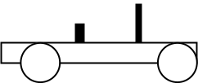
Rubber Band Car System
Wheel & Axle (subsystem)
The wheel and axle transfer energy from the rubber band to the surface to move the car.
A Physical System
Energy Transfer
(Big Idea context)
Boundaries
The Surface
The Person
Rubber band (energy)
Elastic potential energy will be transferred to the wheel and axle subsystem
My hand (input)
A person provides the energy that is stored in the stretched rubber band.
Energy Conservation
Most of the energy results in motion. Some energy is transformed into heat through friction with the surface
Motion (output)
The car moves as a result of the energy that is put into the system.

------------------------------------------------------------------------------------------------------------------------------------------------------------------------------------------------------------------------------------------------------------------------------------------------------------------------------------------------------------------------------------------------------------------------------------------------

Systems Thinking Framework K-1 & 2-3
Whole System
Part

Function of the Part
Name all the parts
Predict: What if a part is missing?
Part

Function of the part
Function of the whole system

Part

Function of the Part
Other systems with a part like this

What form of energy makes this system work?------------------------------------------------------------------------------------------------------------------------------------------------------------------------------------------------------------------------------------------------------------------------------------------------------------------------------------------------------------------------------------

Systems Thinking Framework Grades 4-5

System
Subsystem

function
What the whole system can do.
Inputs
Subsystem

function
Changes in input
Predict the effect of a broken subsystem (part)
Outputs

Describe how the output will change if we change an input?-------------------------------------------------------------------------------------------------------------------------------------------------------------------------------------------------------------------------------------------------------------------------------------------------------------------------------------------------------------------------------------------------------------------------------------------------------------------------------

Systems Example Lessons
The following section provides three example lessons on systems.
- Anchor Lesson- System Centers: An example of an initial lesson on systems concepts. In this lesson students observe a variety of objects with a partner and discuss ideas about whether the objects are systems or not. Students then create their own definition of a system before building a common classroom definition of a system. REMINDER: the important part of this lesson is not that students are correct in identifying systems but that they are engaging in conversations about system concepts. This is also an excellent opportunity for you to uncover their understanding of systems, parts, wholes, inputs, outputs, etc. Listen to their discussions and make public notes of their ideas. The objects can be changed to meet readily available objects in your classroom. See the Systems Center Teacher Guide for an understanding of:
See the next page for more information on how to modify this lesson! Use some systems from whatever kit you have.
- Why these objects were selected
- What ideas these objects may uncover during class discussion

- The Pendulum System: An example of how the “swinger” or pendulum from the FOSS Variables kit could be used to teach systems concepts. This lesson assumes some previous instruction in systems and could be used any time after students have had hands-on experiences with the pendulum system. RECOMMENDATION: you probably would not give students all of these questions to answer. Pick and choose what seems appropriate. Ideally students would be working in pairs or small groups to answer these questions. This basic set of questions could be modified for use with systems from other FOSS kits:
You can use this example as a template for use with LOTS of different systems. Get creative and share what works.
- Other systems from the Variables kit such as FOSS Planes and Catapults.
- Systems in the Levers and Pulleys kit.
- The stream table system in the Landforms kit.

- Toy Boat Science & Literacy Guide (Bethel SD): a lesson for using the picture book Toy Boat to teach systems standards using an interactive read aloud. A great model for using picture books in science.
- Online Systems Lessons: see the links in Appendix B for more examples of lessons that teach K-5 systems ideas.
TEACHER GUIDE
Anchor Lesson: Systems Centers
Purpose: Students will begin to understand the complexity of systems thinking by engaging in an analysis of a variety of everyday objects. Students will create a small group definition for a system and begin to build a classroom definition. WARNING: the definition is less important than the systems concepts you are uncovering and discussing with students (parts, wholes, inputs, outputs, subsystems, etc).
Setup: locate objects (or alternate objects) listed in table below and create centers or stations around the room.
Overview: In pairs, students will observe a variety of objects and discuss whether the objects are systems or not. Students will record yes or no and briefly explain their thinking. As this is happening you will roam the room and listen to their discussions. Note which centers they are struggling with and also whether they are discussing any systems ideas such as: wholes, parts, inputs, outputs, subsystems, etc. Give students time to write their own definitions of a system. Examine a common definition of a system and discuss whether to modify that definition based on their personal definitions
Centers: Any of the objects could be thought of as systems. Watch for reasons why students think they are or are not systems.

OBJECT | Rationale for Using this Object | Possible Student Struggles | Alternate Object
Lamp (or flashlight) | A physical system.  Rich in inputs and outputs of energy. | Doesn’t “do anything” unless turned on | A lava lamp is excellent here!
Soil | Earth materials: contains several “parts” but may seem simple and uninteresting | Lacks distinctive parts  Isn’t “doing anything” | A potted plant  A rock
Magnets | A physical system: Doesn’t seem to have parts yet has an interesting characteristic | Lacks distinctive parts | UV color changing beads
Seeds | A living system: that seems simple yet is very complex. Is this a system if it doesn’t “do anything”? | Lacks distinctive parts  Isn’t “doing anything” | Flower  Worm  Yeast
Balloon (expanded with air) | A physical system: seems simple but is rich in interaction of the internal “parts” of air with “parts” of the balloon | Lacks distinctive parts | Fortune Teller Fish
Pad of Sticky Notes | A physical system: everyday materials that are connected to form something more than a piece of paper | If you remove a note, it is still a pad of sticky notes | Box of Paperclips  Pile of sand
Pencil | A physical system: another everyday object that is familiar | Doesn’t “do anything” with out human input | Pen
Bottle of Water | A familiar physical system: has parts but may not have a clear input and output | Doesn’t seem to be “doing anything” | Cup of water  Can of soda
Options: You may want to include more systems with clear, distinctive parts such as: a toy car, a potted plant, an iPod, a video game controller, other objects from the FOSS kit in your rotation. You may also want to include more living systems (a worm, flower, etc) and more Earth Systems (rocks, clay, sand, etc) or a terrarium, fish tank that contains a variety of interacting systems. See Page Keeley’s Is it a System? Probe from Uncovering Student Ideas in Science vol. 4 p.81)
Anchor Lesson: Systems Centers
- With a partner, observe each of the centers
- Is the object a system or not? Explain your thinking.
- Record your thoughts in the table below.
CENTER | SYSTEM?  YES or NO | EXPLAIN YOUR THINKING
Lamp (or flashlight)
Soil
Magnets
Seeds
Balloon (expanded with air)
Pad of Sticky Notes
Pencil
Bottle of Water
My initial definition for a System:
Return to your table group and do the following:
- Write a one-sentence definition for a System.
- Record your group definition on a strip of paper

Systems Example Lesson
Take a minute to observe the Pendulum. Explore how the pendulum works and what it does when given INPUT.

- Is a Pendulum a system? Please justify your response.
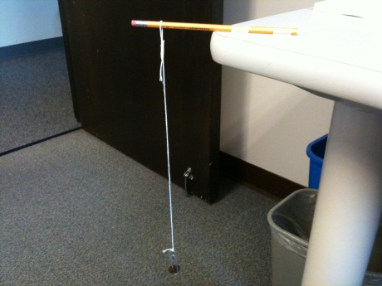

- Identify at least 5 parts of the Pendulum System. If you don’t know the name of a part, make up a sensible name.
- What is the function of each of the parts?
- You may want to make a labeled diagram below.

- The paperclip is one part of the Pendulum System. List three words or phrases that describe the paperclip. Do any of these words or phrases also describe the whole Pendulum System?

- Can any one part of the Pendulum System carry out the job of the whole system? Explain your answer.

- Can you take a part from another Pendulum System and use it to replace a part in this Pendulum System and still have the Pendulum carry out its function?

- Can you identify any subsystems in the Pendulum System? If so, describe one subsystem.

- Is it useful to think of the Pendulum as a system? Justify your answer.


Toy Boat
By Randall de Seve, Illustrated by Loren Long
Systems Science- Literacy Teacher Guide (Bethel SD)

Major themes for this book:
  - Systems – How the parts of a system work together.
  - Systems – System properties are different from any of its parts.

Science Standards (EALR 1):
SYS - Systems
1st:
- SYSA – Describe the parts of the system; compare the parts to the whole.
- SYSB – Identify which parts may be removed without damage to the system.

2nd: Use before FOSS Balance & Motion system language & ideas
- SYSA – Explain how the system’s parts make up the whole system.
- SYSB – Explain how the system depends on each part, or how the system will change if a part is removed.
- SYSC – Explain how the whole system functions differently than any of the parts.
- SYSD – Explain whether the parts must be connected in a certain way for the system to function.

4th: Use before FOSS Magnetism & Electricity system language & ideas
- SYSA – Identify a subsystem of the whole system.
- SYSB – Explain how the whole system can do things that none of the subsystems can do.
- SYSC – Describe the inputs and outputs (especially matter, energy) of the system.
- SYSD – Predict what might happen if one of the parts or subsystems is missing, broken, or improperly connected.
Pre-Reading
- Build students’ initial ideas about systems (use a door, chair, book, etc. as an example system to fill in the blank __________):
The Parts of a ________ System:
- A ‘system’ can be any living or nonliving thing…it can be very small or very big and complicated.
- This _________ system is a system that has many parts that help it work.
- Can you name the parts, and what each part does to help the system work?”

- Collect & chart students’ ideas.
  - Probe them for what they mean, and continue your deliberate use of the words “part,” “________ system,” “function of that part” (or “what does that part do”), and “what other parts is that connected to?”
  - Have students compare the parts to the whole door, chair, or book system

- Get ready to read the story:
- “So, we see how the parts of a system are important to the whole system, but the parts are different from the system. What system do you think is the main character in this story?”
- Open the inside cover to display the parts of the Toy Boat System.
- “What do you think we have here?” Allow students to share a few ideas, but don’t verify.
- Read the story.

Post-Reading
- Select & use some of the questions listed later in this guide.
- Check out the online videos of boat systems—some floating, some sinking.
  - What part or subsystem is OK, or might not be OK in each of these situations?
Literacy Strategies
- (see Making Meaning materials for possible comprehension strategies)
About Systems—Questions to Use with the Story:
In the text & pictures…
- Boy with Toy Boat. [What does the toy boat system do that the little boy likes so much?]
- Close up of Toy Boat. [What are the parts of the toy boat system? See the inside cover.]
- [Why is each part important to the toy boat system?]
- Toy boat in open water. [What problem(s) did the toy boat face?]
- Toy boat in open water. [Which part(s) of the toy boat system were most important for helping it stay afloat?]
- Other, bigger boat systems. [How were the other boat systems similar to or different from the toy boat system?]

Big Boat Systems:
- Tug Boat
- Motor Boat
- Sailboat
- Fishing Boat
- Sloop
- Ferry Boat
Other Questions:
- Two systems of water. [Compare the tub water system to the open water system…Box & T-chart]
- [Describe a “subsystem” of a larger boat that is like one of the parts of the toy boat system.]
- Make “Big Boat System Cards” to assign student teams to focus on one Big Boat in answering the prompt above.

Online Videos Boat Systems, and Their Problems
(What part or subsystem is OK, or might not be OK in each of these situations?):
- (video 3min.) Sinking a toy boat http://www.youtube.com/watch?v=IfNBapmVbrw
- (video 1min.) Launch of a brand-new NOAA ship http://www.youtube.com/watch?v=p15Wg68ymec&feature=related
- (video 1min.) Brand-new ship launch goes bad http://www.youtube.com/watch?v=IPoAOXf8RIo&feature=related
- (video 3min.) Problems with professional sailboats http://www.youtube.com/watch?v=LA-REPv-ReY

Opportunities for teaching Systems standards in FOSS kits

Grade 5 has opportunities for teaching Systems Standards within every current kit in the rotation.
Grade 4 has rich opportunities in the Electricity and Magnetism kit. This is where instructional time on Systems Standards should be focused in grade 4.
Grade | Kit | Investigation | Activity Ideas | RESOURCES
5 | Variables | Swingers | As an extension after conducting the investigation with the swingers:  Use a Systems Framework sheet to examine the following questions.  What are the parts of the swinger system? What do the parts do?  What would happen if the tape wasn’t “sticky”?  What is the input?  What is the output?  Use the Pendulum System lesson | Systems Handbook  Systems Questions  WA Science Standards  WA 5th Grade MSP Test & Item Specs  Example Systems Lessons: Systems Centers and Pendulum System  Systems Thinking Framework grade 4-5
5 | Variables | Lifeboats | Analyze the Lifeboat and tub of water as a system
5 | Variables | Plane Sense | Analyze the FOSS Plane as a system. Great opportunity to discuss input, output, and energy transfers/transformations.
5 | Variables | Flippers | Analyze the Flipper as a system. Another opportunity to discuss inputs, outputs, and energy.
5 | Landforms | 2- Stream Table  3- Go with the Flow | Analyze the Stream Table as a system. This is a good opportunity to discuss inputs and outputs.
5 | Levers and Pulleys | Any | Analyze any of the objects as systems. Opportunities to discuss subsystems.
4 | Magnetism and Electricity | Any | Analyze a circuit as a system. EXCELLENT opportunity to identify flow of energy through a system and to analyze parts, subsystems, input, output, and, predict what will happen when a part is broken.
4 | Earth Materials | NONE | No clear systems connections here
4 | Ideas and Inventions | Limited | Analyze one of the inventions (periscope) as a system.

Systems Scenario Guidelines

Systems scenarios describe a physical, Earth/space, or living system. Systems scenarios may include systematic observations, models, or open-ended explorations of a system.
General Description of a System
The following characteristics are common to Systems scenarios.
A Systems scenario explores only one system. There may be subsystems within the system, and the system may be part of a larger system; however, the focus of the scenario should be a single system.

A short introduction defines the system by describing the system as an object or as connections of objects within defined boundaries.

State Tree
The state tree for Washington is the Western Hemlock. The Western Hemlock tree is an important part of many forest ecosystems in Washington State.
The seeds of a hemlock tree can be found in the cones made by the tree. The Western Hemlock Tree diagram shows the cones on the branches.
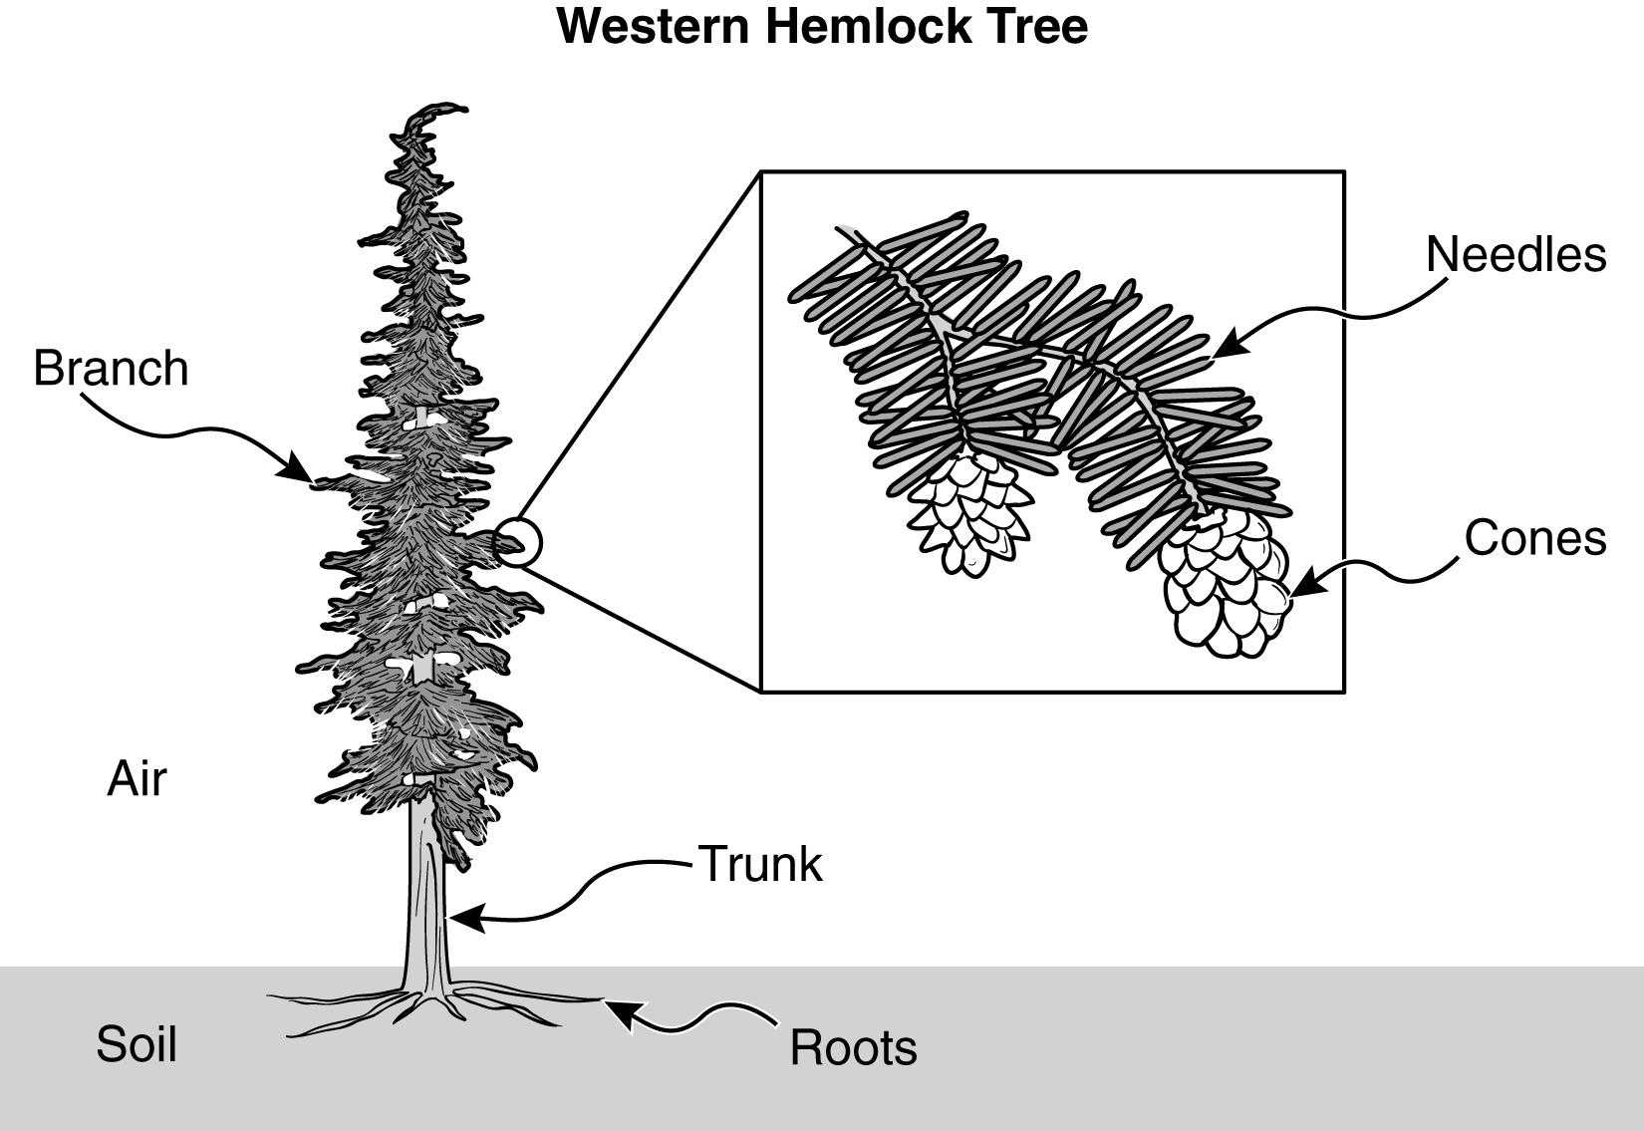

Additional text can describe a phenomenon that occurs within that system, including descriptions of the inputs, transfers, and/or outputs of matter, information, and/or energy in the system.

A labeled diagram of the system defines the boundaries of the system and labels the parts of the system.

(This released scenario is provided as an example.)

Example Systems 5th Grade MSP Scenarios

A. Feathered Friends

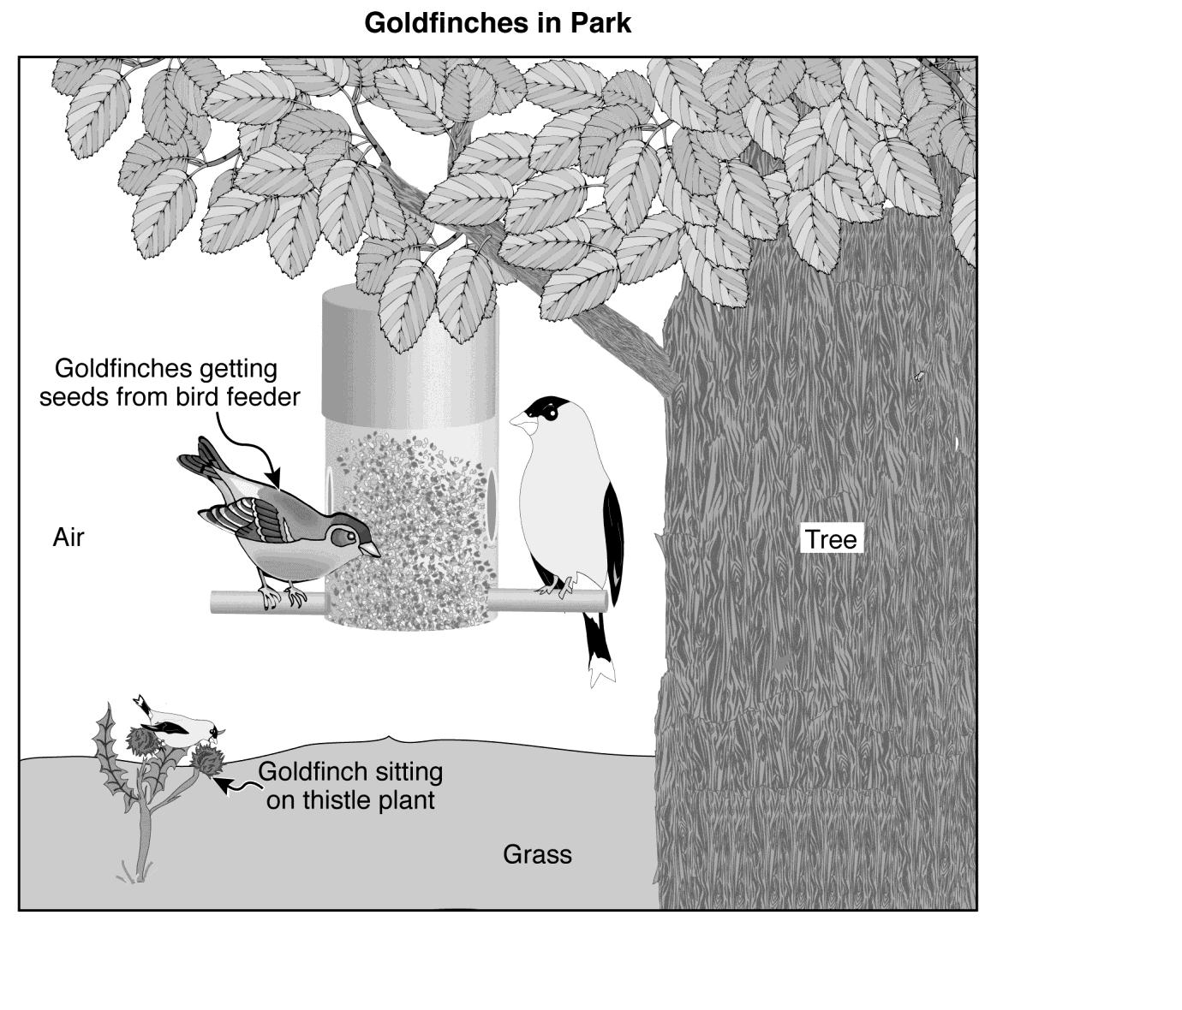
Cole and Bella observed two goldfinches getting seeds from a bird feeder in a park. They also saw a goldfinch sitting on a thistle plant as shown in the Goldfinches in Park diagram.
What kinds of systems questions could you ask with a scenario like this? Look at the Questions to Ask about Systems for some ideas.

Systems Measurement Topics and Rubrics
Created by regional science coordinators and Marzano Research Labs

Science Measurement Topics | K-1 | 2-3 | 4-5 | 6-8 | 9-12
Big Idea: Systems
Parts and Wholes | +
Taking Objects Apart | +
Systems |  | + | +
Interdependence of Parts |  | +
Functions of Wholes and Parts |  | +
Connection of Parts |  | +
Similar Parts |  | +
Subsystems |  |  | +
Inputs/Outputs |  |  | + | +
Damaged Systems |  |  | +
Subsystems |  |  |  | +
Boundaries |  |  |  | +
Open and Closed Systems |  |  |  | +
Matter and Energy in Systems |  |  |  | +
Complex Systems |  |  |  | + | +
Feedback in Systems |  |  |  |  | +
Systems Thinking |  |  |  |  | +
Equilibrium in Systems |  |  |  |  | +

The following page contains sample rubrics for scoring student understanding of the Washington State Systems Standards in K-5. For a complete set of rubrics, see the link below:

http://science.esd105.org/images/stories/Marzano_Rubrics/Overview/WA_Science_by_Grade_K-12_.docx
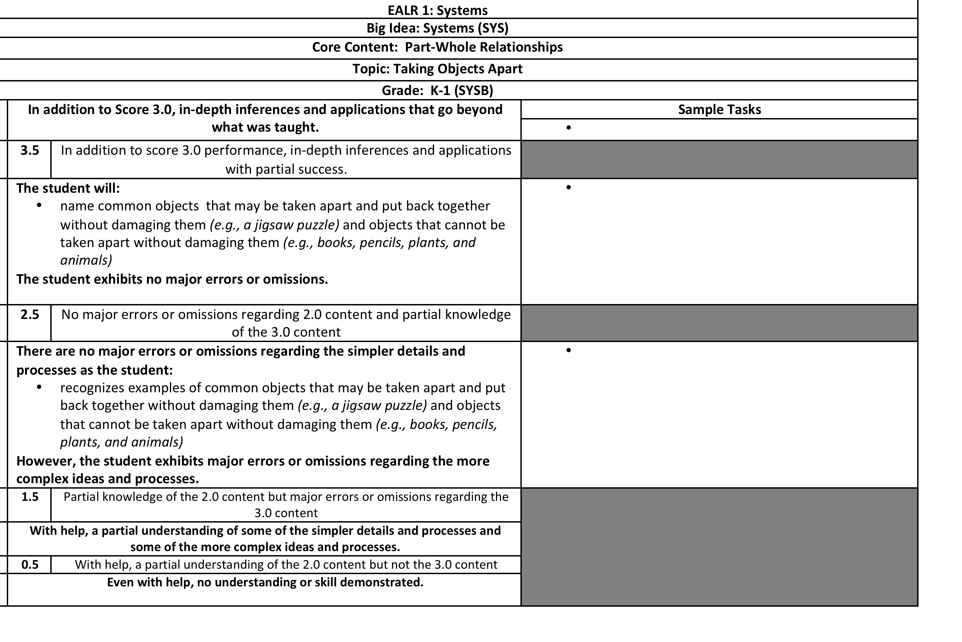
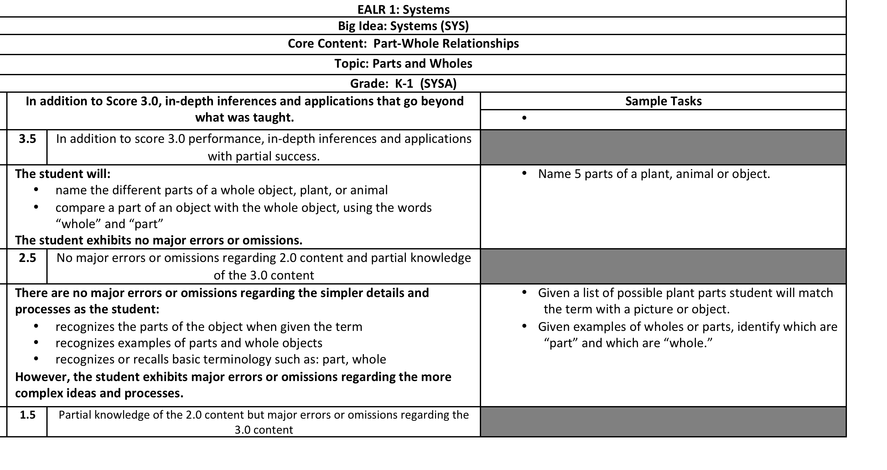
APPENDIX A: Systems Vocabulary
Reminder: it is less important for students to memorize the definition of a system than it is for them to develop the critical thinking skills of a systems thinker.

The following are examples of ‘student friendly’ definitions that a teacher and students might create together to better understand systems standards.

System: A group of parts that interact to make a whole.

Subsystem: Parts that work together to make a larger system.
Encourage students to create (draw, write, diagram) an initial definition and then revise their definitions after talking with a partner, listening to class discussions, and engaging with other sources of evidence: hands-on experiences, text, etc.

Input: Matter, energy, or information flowing into a system.

Output: Matter, energy, or information that flows out of a system.

Whole: Connected parts that make a complete system.

Part: One piece of a system that has a specific role or function

Function: The purpose or role of something. What something does… It’s job.

Matter: The “stuff” of the world. There is solid, liquid, and gas “stuff”.

Forms of Energy: Light, heat, motion, sound, and electricity are energy.

APPENDIX B: Systems Resources

Resource | Potential Uses
Systems in National Standards Documents
Systems Standards Benchmarks Online | Provides more depth to systems in WA science standards
Systems in Science for All Americans Online | Provides a broad definition of systems
Systems Maps on NSDL | Provides a learning progression for systems ideas K-12
Framework for K-12 Science Education Standards (Systems as a Cross Cutting Idea) | Provides a look at how systems will be an important cross cutting concept in the upcoming Next Generation Science Standards
Example Systems Lessons Online
Exploring Parts & Wholes | K-2 lesson on parts and wholes from Science NetLinks
Ready, Set, Let’s Dough! It’s a Matter of System | K-2 lesson on parts and wholes from Science NetLinks
Systems 1: Simple Machines | A 3-5 lesson parts, functions of parts, and interactions of parts
Systems 2: Systems, Up, Up and Away! | A 3-5 lesson that integrates design, variables, and systems ideas in testing a Film Canister Rocket. (You could substitute a stomp rocket, straw rocket, paper airplane, etc.. and use a similar lesson structure)
Bicycle as a System | Middle school lesson (grades 6-8)
Washington State Science Resources from OSPI
Washington Science Learning Standards (2009) | Examine systems standards for K-1, 2-3, and 4-5.
5th Grade Science MSP Test & Item Specifications | Examine systems ideas that 5th grade students will be tested on.
Kent School District 5th Grade Science MSP Practice: Activities and Resources (available winter 2012) | Students practice and learn about the 5th grade Science MSP using Systems scenarios, Inquiry scenarios, and Application scenarios.
5th Grade Science MSP Released Items | A spreadsheet of all release 5th grade science items.

