Take a minute to observe the Ladybug Toy. Explore how the toy works and what it does when given INPUT.

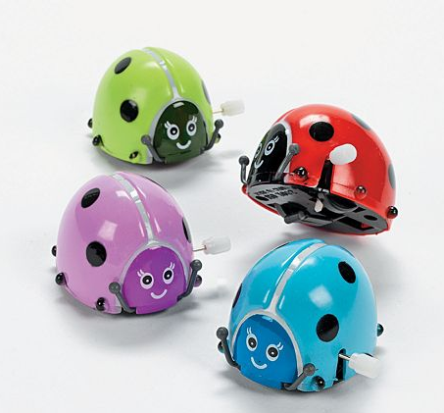
- Is this toy a system? Please justify your response.

- Identify at least 6 parts of the Ladybug Toy System. If you don’t know the name of a part, make up a sensible name.
- What is the function of each of the parts?
- You may want to make a labeled diagram below.

- The wheels are one part of the Ladybug Toy System. List three words or phrases that describe the wheels. Do any of these words or phrases also describe the whole Ladybug Toy System?

- Can any one part of the Ladybug Toy System carry out the job of the whole system? Explain your answer.

- Can you take a part from another Ladybug Toy System and use it to replace a part in this Ladybug Toy System and still have the toy carry out its function?

- Can you identify any subsystems in the Ladybug Toy System? If so, describe one subsystem.

- Is it useful to think of the Ladybug Toy as a system? Justify your answer.

- Challenge Question: You cannot observe the inside of the Ladybug Toy System. (Please DO NOT open it) Using your observations of the external parts of the Ladybug Toy System- predict what the internal parts of the Ladybug Toy System might be. Draw a labeled diagram of your prediction below.

